**Lab 4 Part 2: Advanced Tableau II (Updated):**

**Khush**

6. Edit and Save a Data Source:

Use the hurricane.xlsx;

1. . Create a folder and assign fields to the folder;

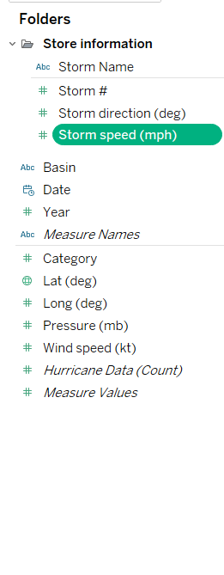

1. . Change dimension to measures, or change measures to dimension (storm #):

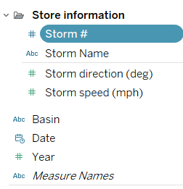

1. . Set the default properties of the fields;

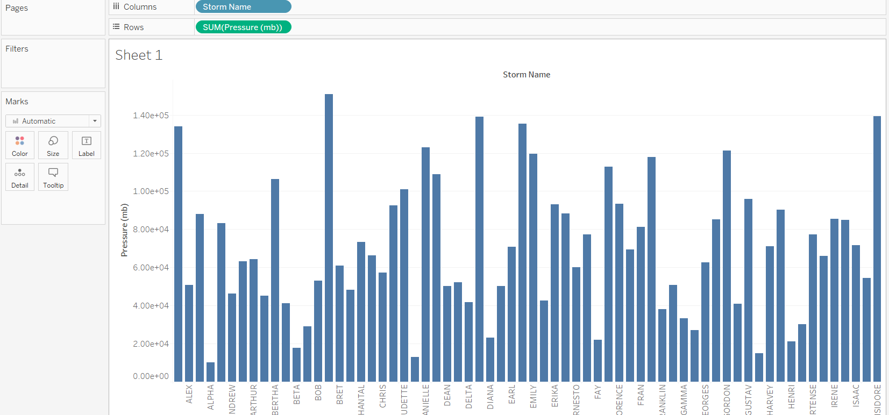

1. . Rename a field;

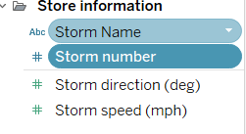

(5). Save the data source locally or to the server;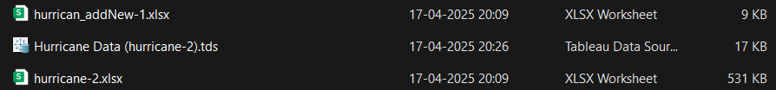

7. Update the View with New Data:

(1). Live connection;

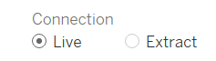

1. . Automatically change the views by changing data;

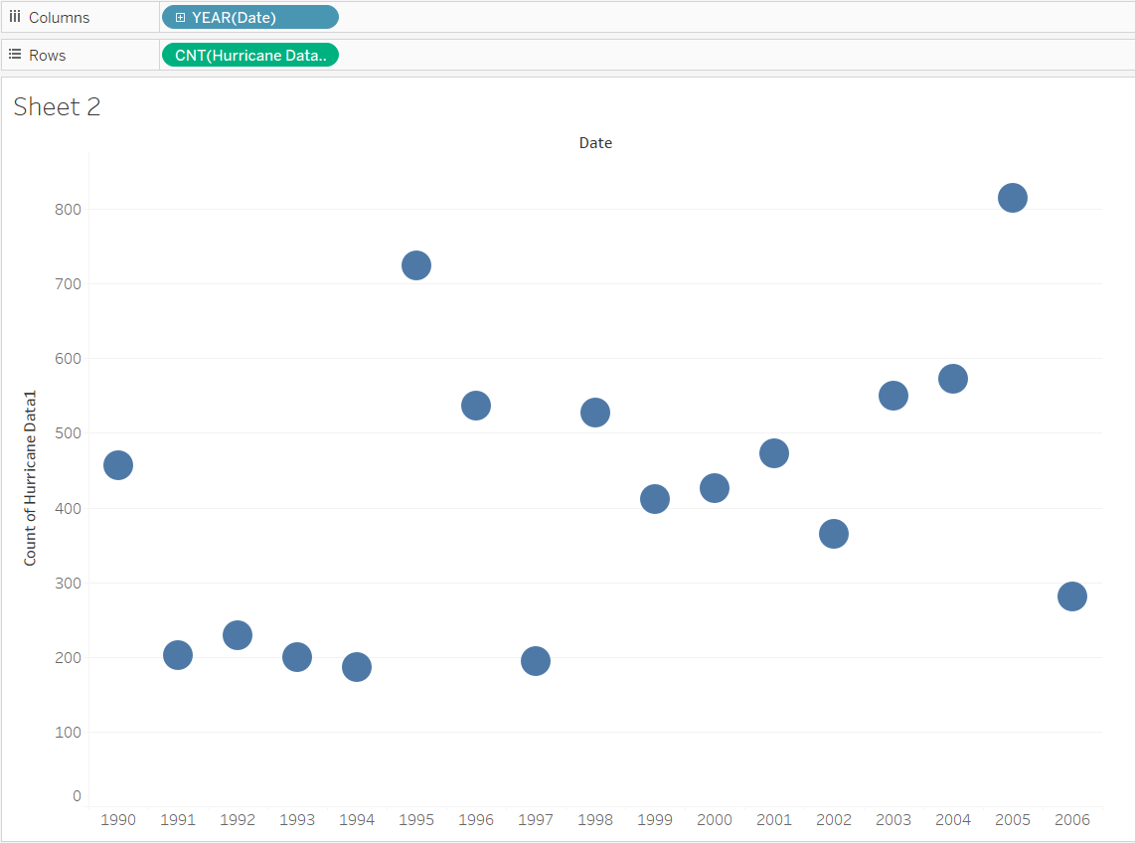

1. . Structure change won’t be applied to the views directly;

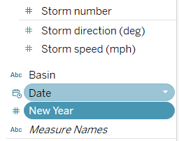

8. Use Groups to organize Data:

(1). Use Group to categorize Product “Model Name”; Use rename to change the name of the

group;

(2). Use Find to discover the keywords for categorization; Use the other to include the remaining

items into one group;

(3). Model Sum of Quantity by Model Groups: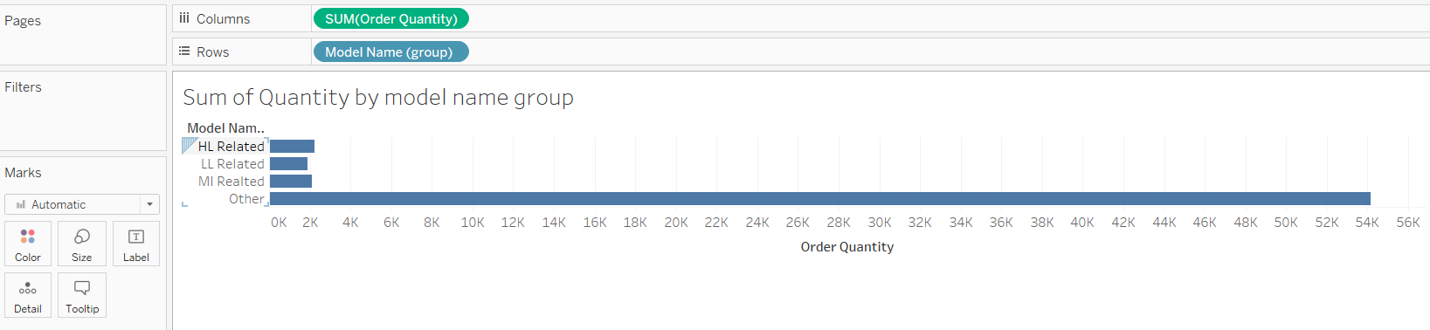

1. . Group the items in the View by labels (Use product line and sum of the sales amount):

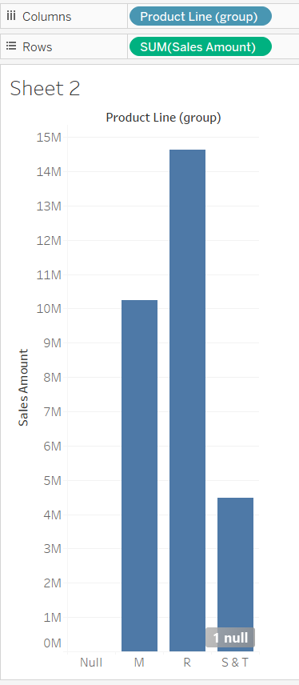

1. . Compare different groups using bars by different colors (use Size, sum of order quantity):

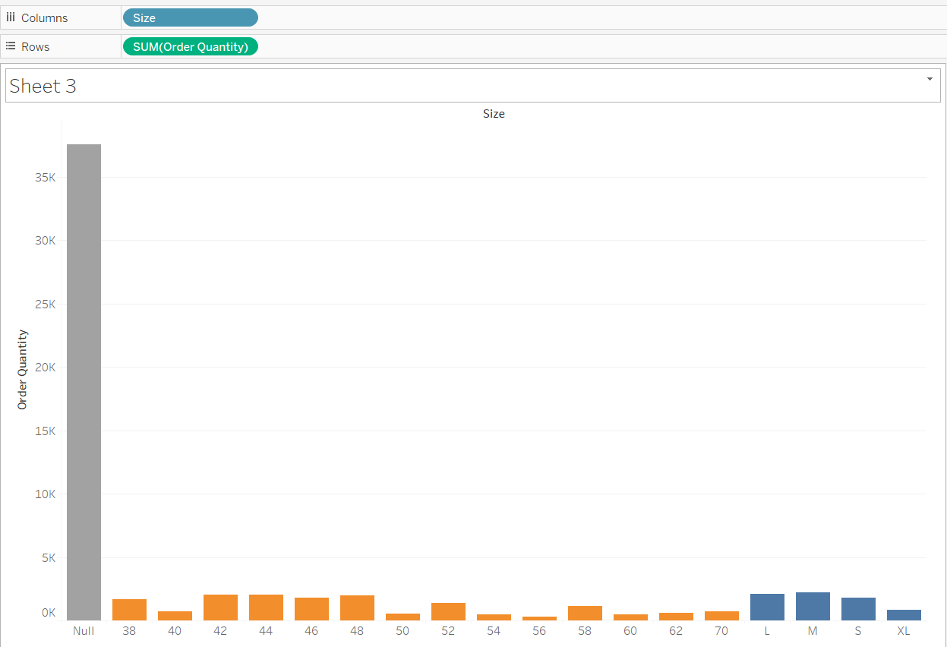

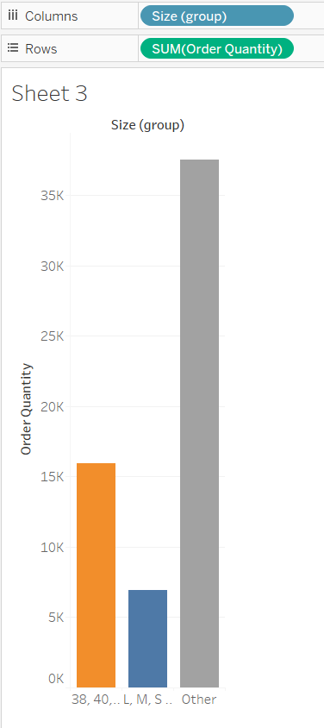

9. Use Hierarchy to organize data:

(1). Create hierarchy using Customer Information;

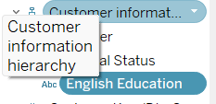

1. . Create a bar chart using the Customer hierarchy and Sum of quantity;

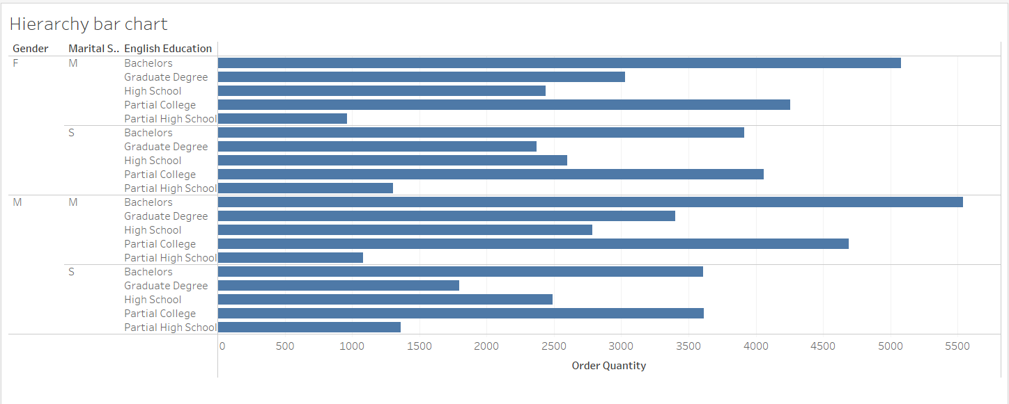

10. Working with Discrete and Continuous Date Fields:

(1). Use continuous date field, when you want to view data over time; See the sum of the sales

amount of months over year;

We can observe the sum of sales changes or trends across different years from different month

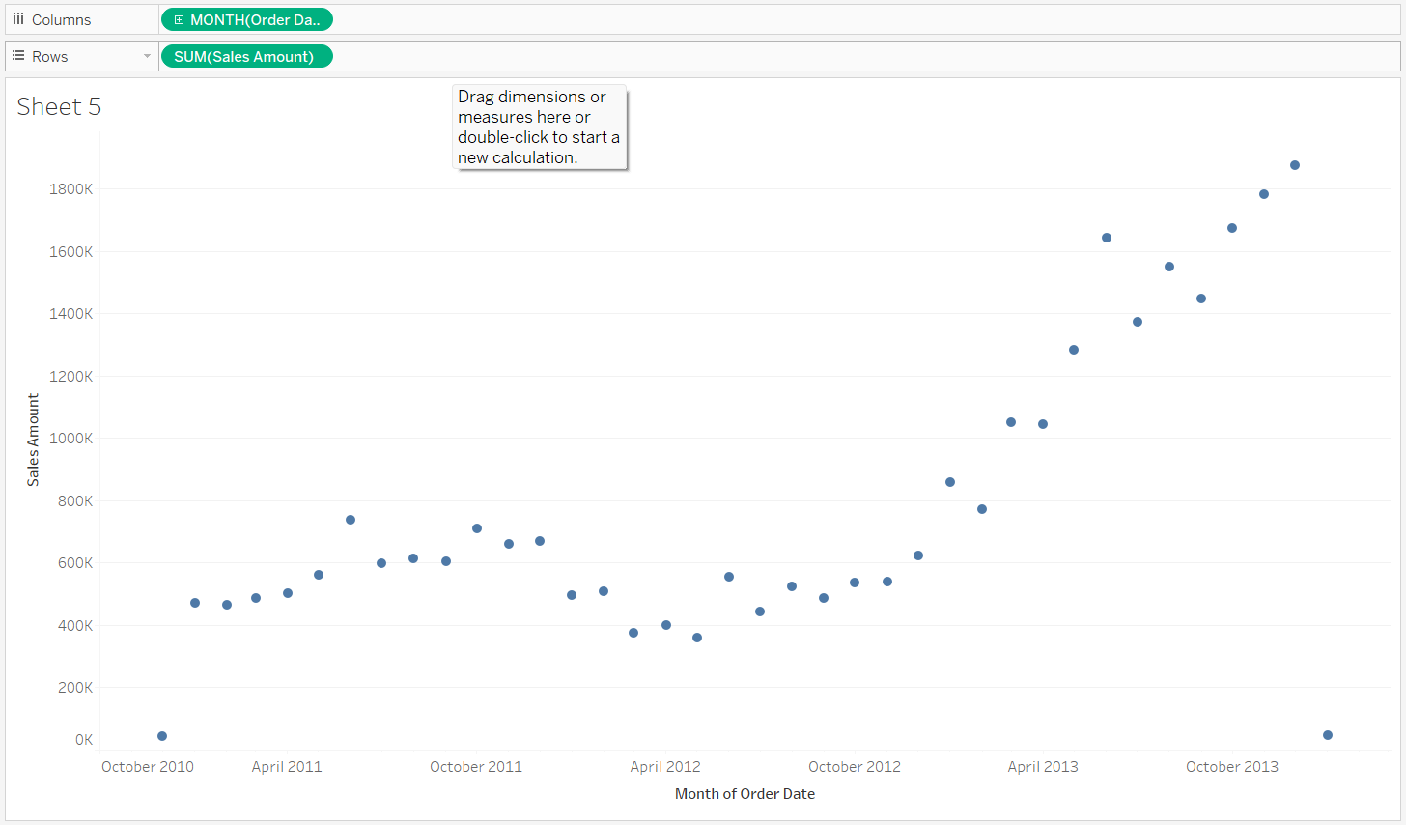

(2). Use discrete date field, when you want to view data comparison amongst categories (e.g.

month); See the sum of the sales amount of months from different years;

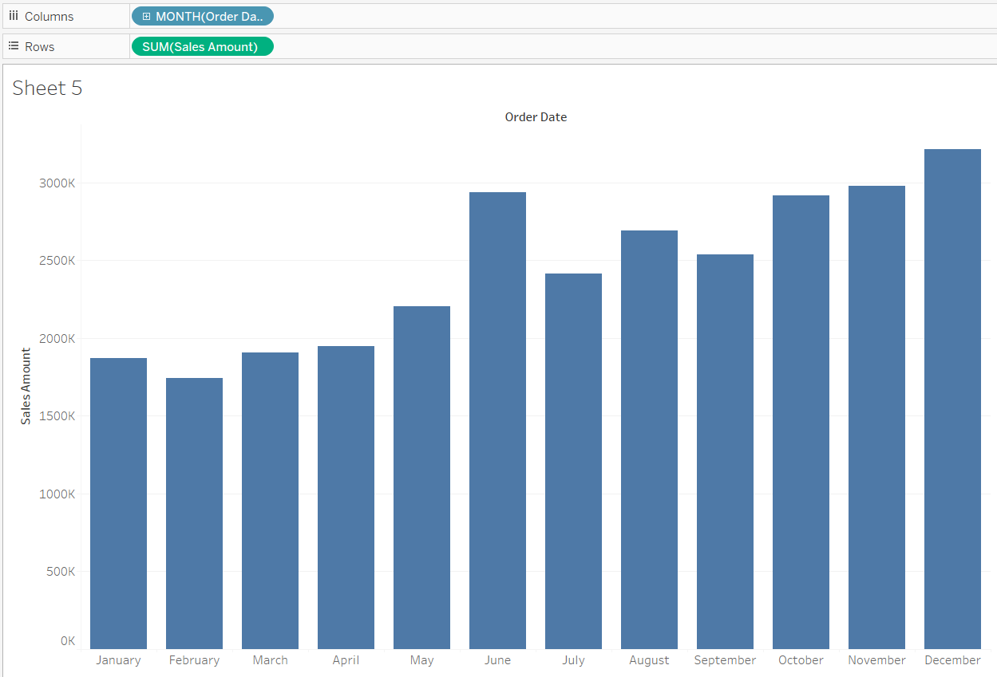

1. . Use different hierarchies and combinations of the date;

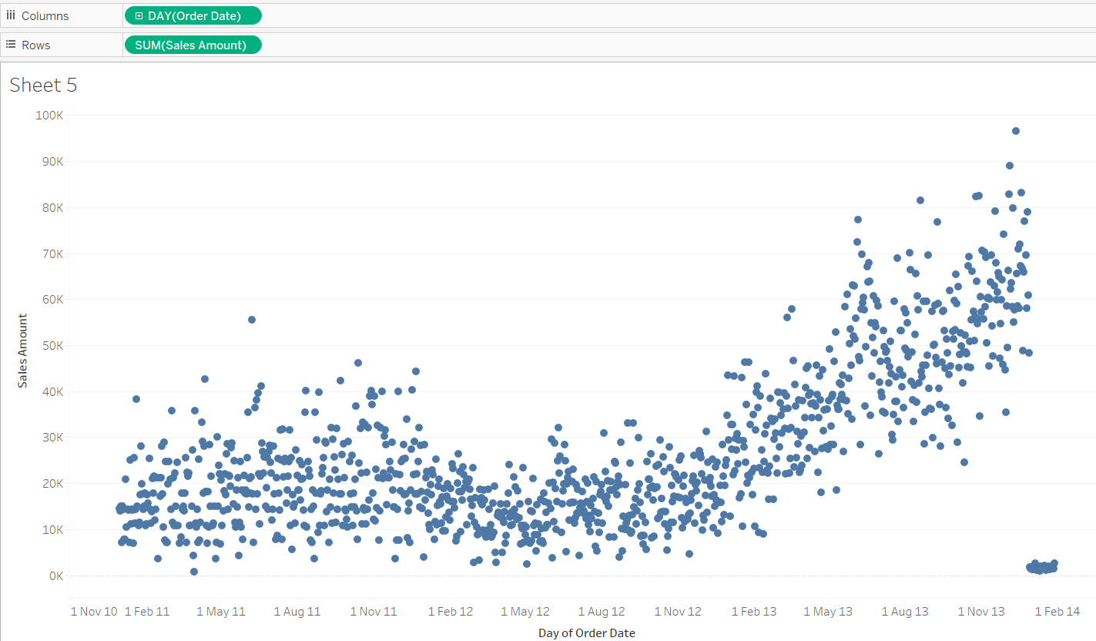

1. . Use colors for different months in a year (dimensions and measurements);

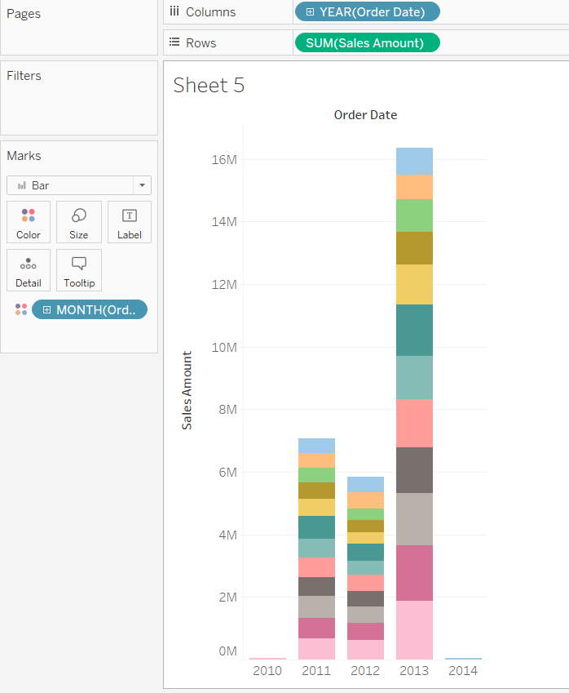

1. . Use continuous and discrete date as a filter;

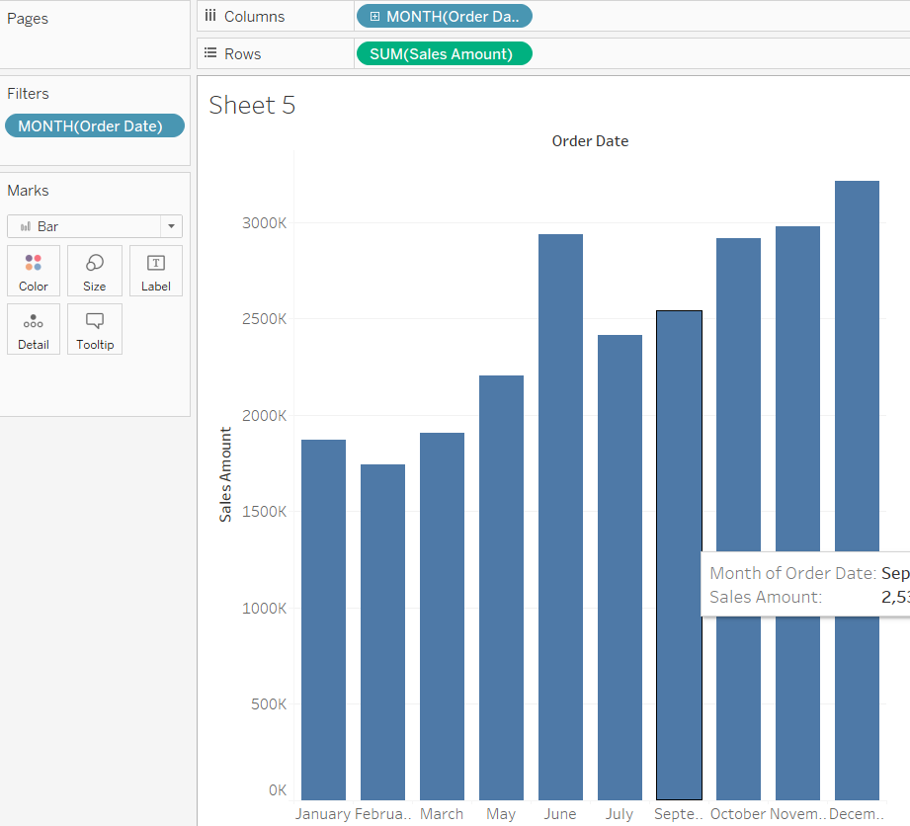

1. . Create custom date: Discrete month and continuous month;

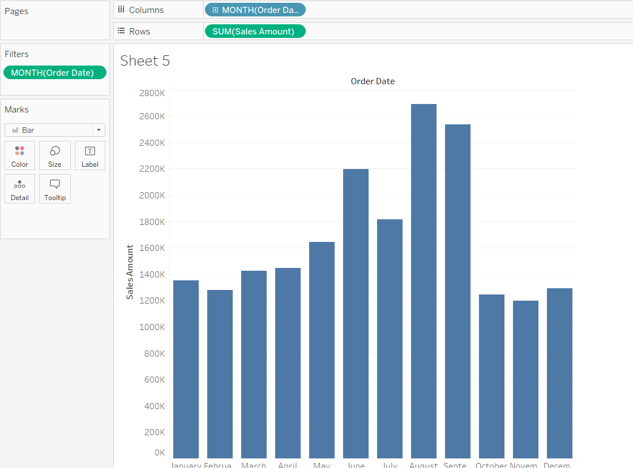

---------------------------------------------------------------------------------------------------------------------

3. Dual Axis and Combo Charts:

(1). Create a Dual Axis with Month of the Order Date, Sum of the Tax Amount, and Sum of the Sales Amount;

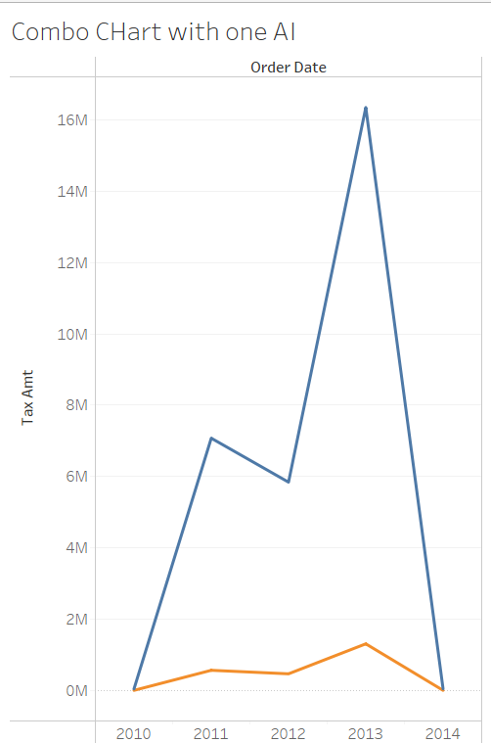

(2). Change the axis at the same unit of analysis;

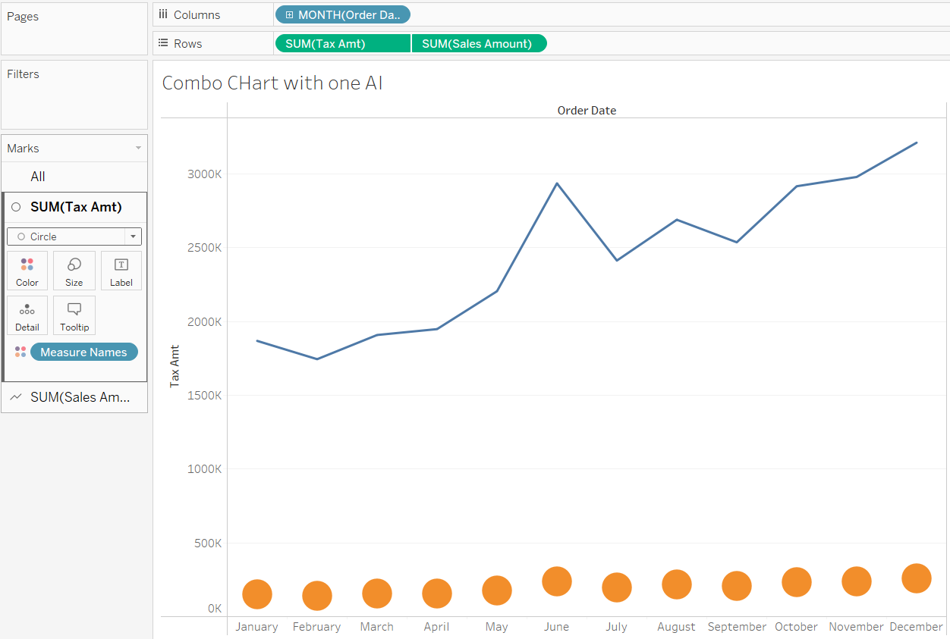

1. . Use different chart types in one view: combo chart:

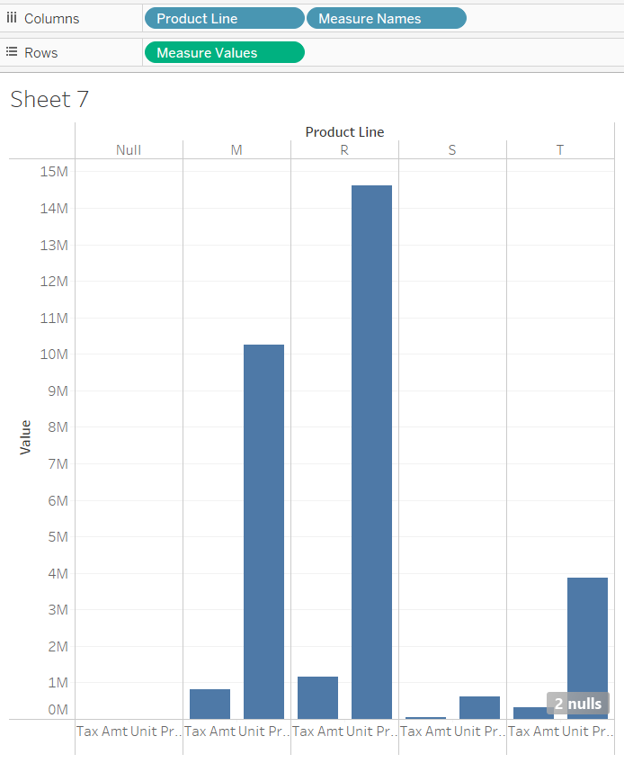

4. Building a combined axis chart:

(1). Add sum of the Tax Amount, sum of the Unit Price, sum of product standard cost in a combined axis chart, categorized by Product Line:

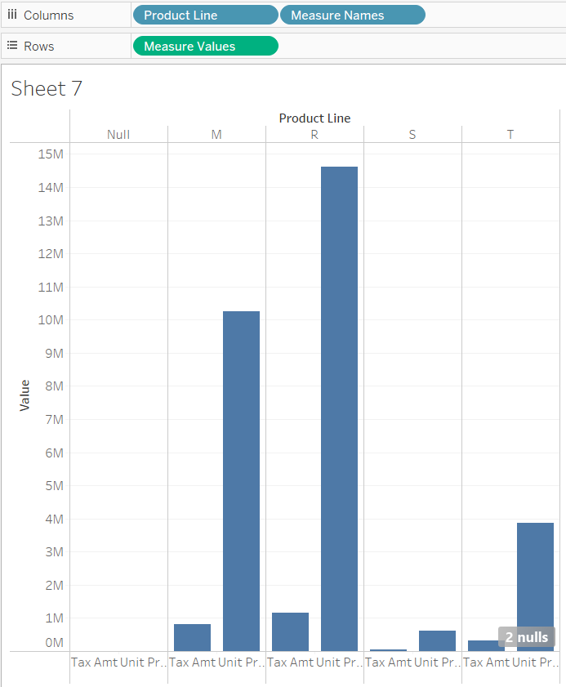

1. . Use Measure Names in the filter to add sum of product cost in the combined axis:

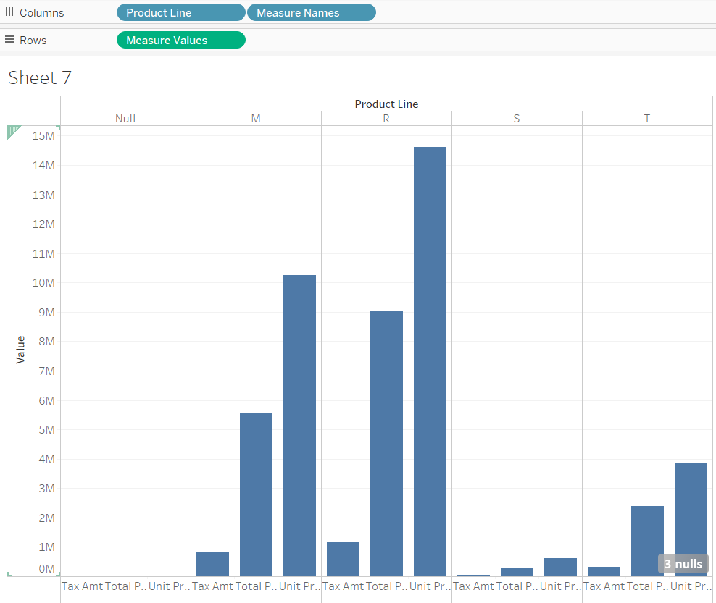

1. . Use color marks for additional comparison;

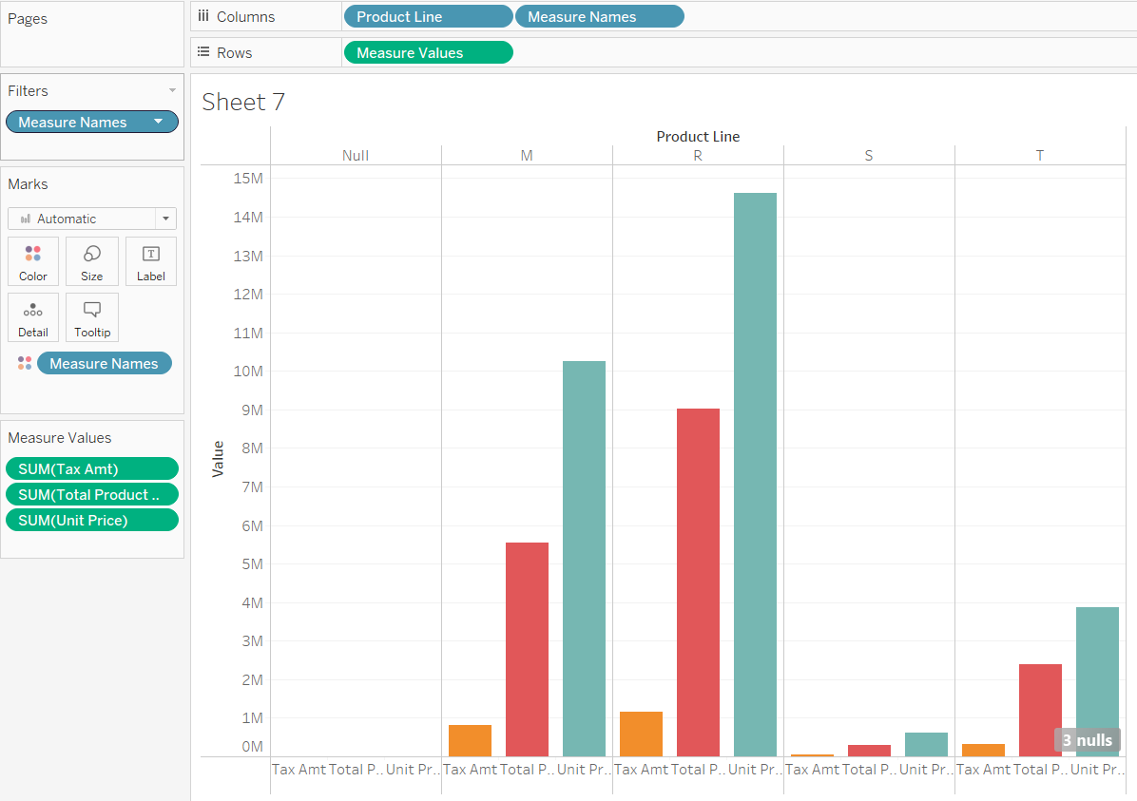

(4). Create a combined axis stacked chart;

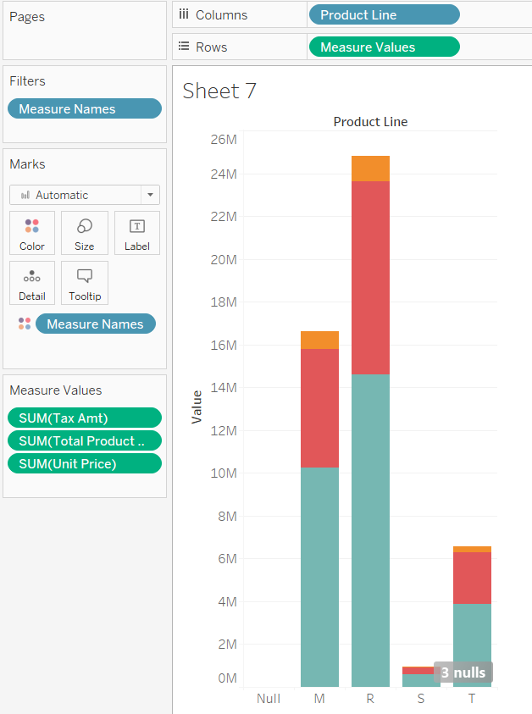

5. Create Scatter Plot:

(1). Create scatter plot with two measurements (cost and sales)(aggregated), but add dimensions for more detail;

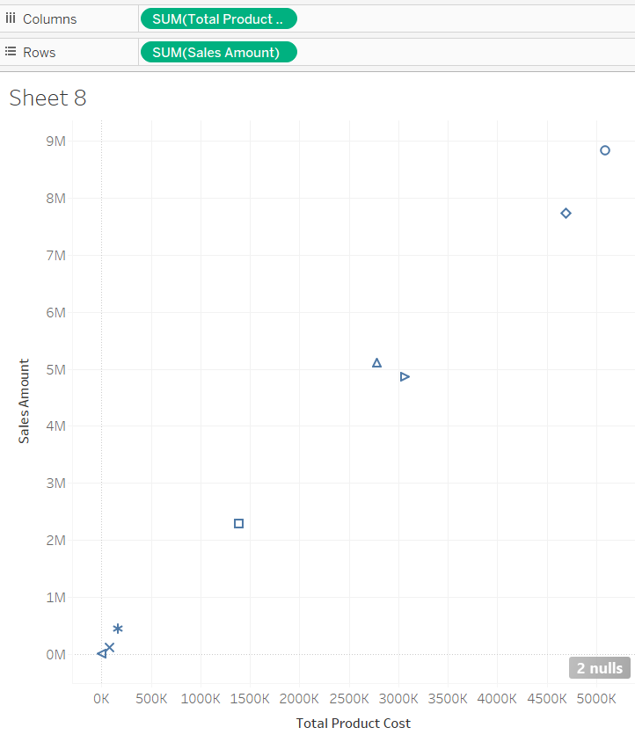

1. . Create scatter plot with two measurements (non-aggregated);

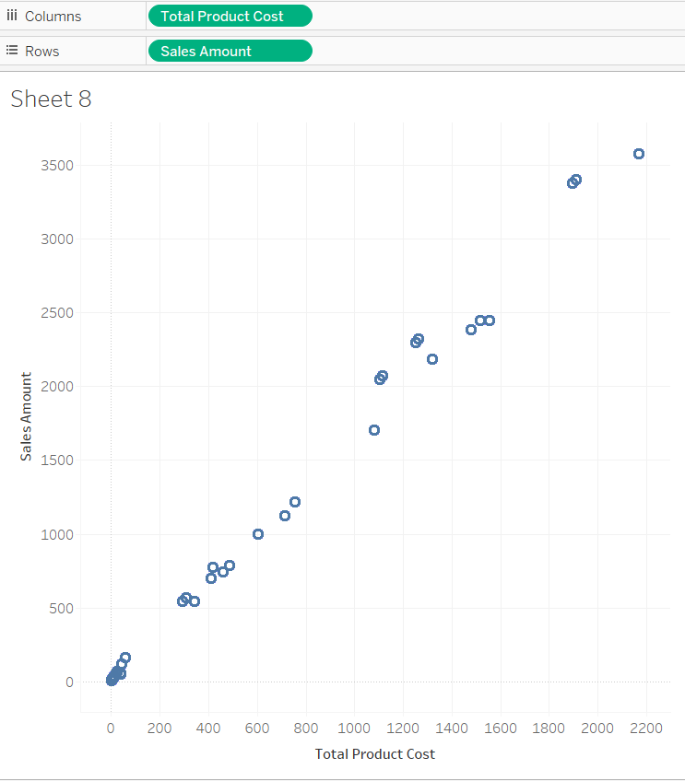

6. Creating a symbol map:

(1). Create a map view to compare sum of the sales amount by country;

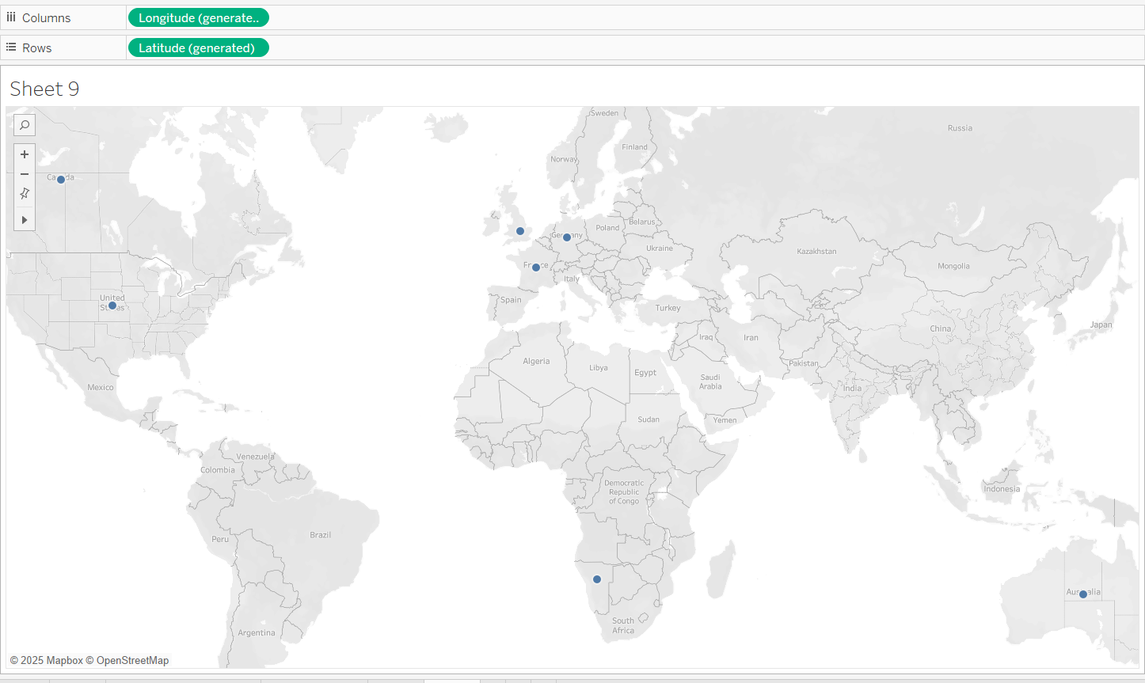

(2). Create a map view to compare sum of the sales and sum of the total product cost using sizes and colors; Edit Map layers to change the map view.

